

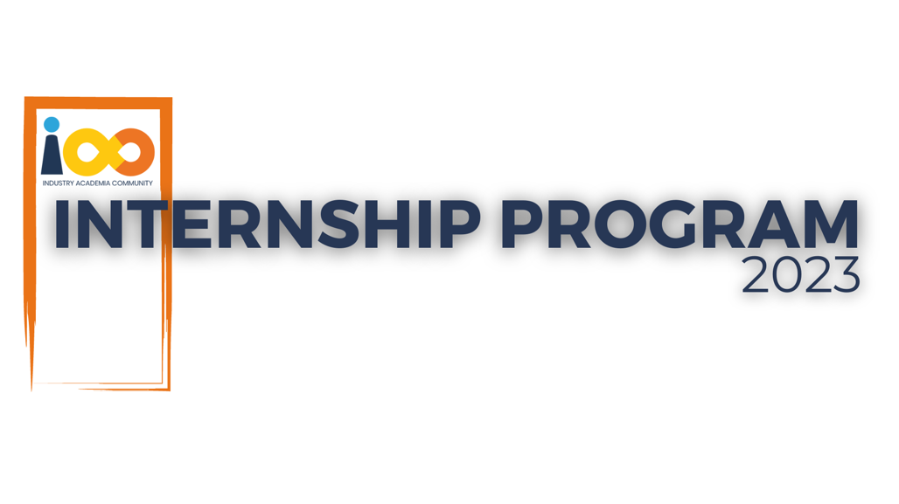

PROJECT REPORT

Machine Learning  
  
Predictive Placement Status

and

Graduation Year Calculation

|  |  |  |  |
| --- | --- | --- | --- |
| **Created By:** | Mohammed Abdur Rasheed | **Approved By:** | <Domain Lead Name> |
| **Created On:** | 05-09-2023 | **Approved On:** | DD-MMM-YYYY |

Page left blank intentionally

**INDEX**

**1** **PROJECT DETAILS** 2

**2** **SUMMARY** 2

**3** **INTRODUCTION** 2

3.1 Background 2

3.2 Stakeholders 2

3.3 Objectives 2

**4** **METHODOLOGY** 2

4.1 Considerations & Assumption 3

4.2 Approach 3

4.3 Activities 3

**5** **TARGETTED V/S ACHIEVED OUTPUT** 3

**6** **CONCLUSION** 3

**7** **APPENDICES** 4

7.1 Appendix A – Title 4

**General Instructions for using the Live Project Report Template**

* This template and the subsequent document created using this template is a confidential document and is the intellectual property of Cloud Counselage Pvt. Ltd. Circulating it outside of the organisation without the consent of Cloud Counselage Pvt. Ltd. is the breach of company policies and will lead to legal actions
* This template is a guideline document to communicate the implementation of design ideas and the results of the work to the stakeholders.
* The **text between inequality (< >) is to be replaced** by relevant text
* Please **remove the yellow highlight on the Text** between the inequality (< >). This is done to help you notice the text to be changed/replaced
* The text in *italics* highlighted in grey is just for reference and should be removed after adding the relevant text

# **PROJECT DETAILS**

|  |  |  |  |
| --- | --- | --- | --- |
| **Project Name** | Predictive Placement Status and Graduation Year Calculation | | |
| **Project Sponsor** | Tushar Topale | | |
| **Project Manager** | Harshada Topale | | |
| **Start Date** | 31-07-2023 | **Completion Date** | 05-09-2023 |

# **SUMMARY**

The project aimed to achieve two main objectives:

1. Calculate the graduation year of students based on their academic year.
2. Predict the placement status of students based on various attributes.

These objectives were driven by the need to streamline data processing and provide insights into student data for better decision-making. The long-term benefits of this project include improved data accuracy, faster data processing, and more informed placement decisions.

# **INTRODUCTION**

## Background

This project originated from the need to efficiently process and analyze student data for better decision-making. The project involved two main tasks: calculating graduation years and predicting placement statuses.

## Stakeholders

The stakeholders involved in this project is Harshada Topale, Project Manager at Cloud Counselage Pvt. Ltd.

## Objectives

The objectives of this project, as outlined in the Project Charter, were successfully achieved. The project delivered accurate graduation year calculations and placement predictions based on the provided data.

# **METHODOLOGY**

These conventions are all about the positions of line breaks, how many characters should go on a line, and everything in between.

## Considerations & Assumption

The project considered potential constraints and challenges, such as missing data and data quality issues. Assumptions were made to handle missing data and ensure data accuracy.

## Approach

A structured approach was adopted, including data preprocessing, machine learning model development, and result reporting.

## Activities

The project activities included data preprocessing, model development, and testing on both training and test datasets.

# **TARGETTED V/S ACHIEVED OUTPUT**

The targeted outputs, as defined in the project plan, were successfully achieved. Graduation year calculations and placement predictions met the project's objectives. Deviations, if any, were minimal and did not impact the overall project success.

# **CONCLUSION**

The project has successfully delivered accurate graduation year calculations and placement predictions. This will prove valuable for both the educational institution and the placement department. The future scope of this project includes the potential for further enhancing prediction accuracy and scalability.

# **APPENDICES**

## Appendix A – Title